LAB # 05
Dom Manipulation, Selectors , Events and Call Back Functions

What is the DOM?
The DOM is a W3C (World Wide Web Consortium) standard.
The DOM defines a standard for accessing documentWhat is the HTML DOM?
The HTML DOM is a standard object model and programming interface for HTML. It defines:
- The HTML elements as objects
- The properties of all HTML elements
- The methods to access all HTML elements
- The events for all HTML elements
In other words: The HTML DOM is a standard for how to get, change, add, or delete HTML elements.
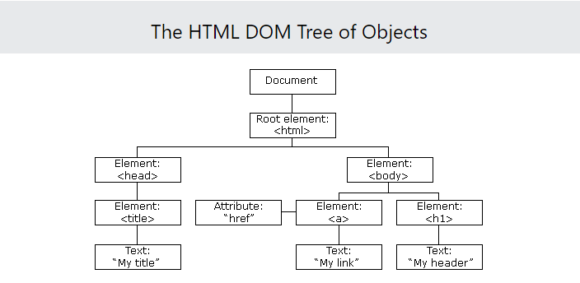

DOM manipulation is interacting with the DOM API to change/modify the HTML document that is to be rendered on the web browser. This HTML document can be changed/modified to add elements, remove elements, edit elements, move elements around, etc.
By manipulating the DOM you can create applications that will update the data of the page without a refresh, change the layout of a page without a refresh. You can shuffle, move or delete elements across the document.
Many languages are used to manipulate the DOM. We will be using Javascript to do so. Consider this HTML document, we will be performing DOM manipulation on it:

- Selectors

<!DOCTYPE html>
<html>
<body>
<h1>DOM LAB 5</h1>

<h2> 1. getElementById() </h2>
<p id="demo"></p>
<script>
document.getElementById("demo").innerHTML = "Hello World";

document.getElementById("demo").style.color = "red";

</script>
</body>
</html>

<!DOCTYPE html>
<html>
<body>
<h1> DOM LAB 5</h1>
<h2>2. getElementsByClassName() Method</h2>
<p>Change the text of the first element with class="example":</p>
<div class="example">Element1</div>
<div class="example">Element2</div>
<script>
const collection = document.getElementsByClassName("example");
collection[0].innerHTML = "Hello World!";
</script>
</body>
</html>
<h1> DOM LAB 5</h1>
<h2>The document.getElementsByName Method</h2>
Cats:<input name="animal" type="checkbox" value="Cats">
Dogs:<input name="animal" type="checkbox" value="Dogs">
<p>Number of elements with name="animal" is:</p>
<p id="demo"></p>

<script>
let num = document.getElementsByName("animal").length;
document.getElementById("demo").innerHTML = num;
</script>

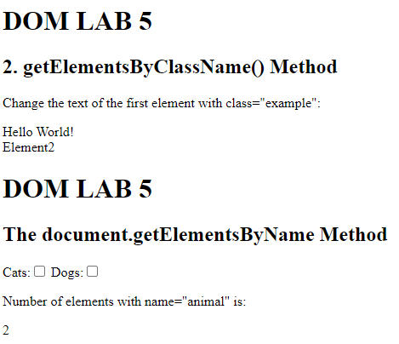
<h1> DOM LAB 5</h1>
<h2>The getElementsByTagName() Method</h2>
<p>An unordered list:</p>
<ul>
<li>Coffee</li>
<li>Tea</li>
<li>Milk</li>
</ul>
<p>The innerHTML of the second li element is:</p>
<p id="demo"></p>

<script>
const collection = document.getElementsByTagName("li");
document.getElementById("demo").innerHTML = collection[1].innerHTML;
</script>

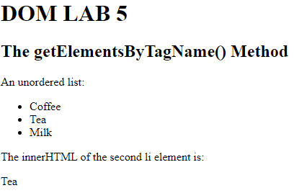
- Events
Events are fired to notify code of "interesting changes" that may affect code execution. These can arise from user interactions such as using a mouse or resizing a window, changes in the state of the underlying environment (e.g. low battery or media events from the operating system), and other causes.

<div>
<p class="name"> WEB ENGINEERING 6A</p>
<button>Change Color</button>
</div>

<script>
const name = document.querySelector(".name");
const btn = document.querySelector("button");
btn.addEventListener("click", function () {
name.style.color = "blue";
});
</script>

HTML
<h1>Changing the Style</h1>
<p>JavaScript can change the style of an HTML element.</p>

<button type="button" onclick="openMe()">Open!</button>
<button type="button" onclick="closeMe()">Close!</button>

<p id="demo">Extra details...You can open and close this paragraph using the buttons above.</p>
CSS:
.closed{
display: none;
}
.open{
display: block;
}

button{
width:150px;
background-color: #00CCEE;
margin-left:15px;
font-size:120%;
}

#demo{
color:white;
background-color: #7F7F7F;
padding:10px;
font-size:120%
}

JS:
function closeMe(){
// Find the element
x=document.getElementById("demo");
//Option 1: Change the style attribute directly
x.style.display="none";

//Option 2: Change the class
// x.className="closed";
}

function openMe(){
// Find the element
x=document.getElementById("demo");
//Option 1: Change the style attribute directly
x.style.display="block";

//Option 2: Change the class
// x.className="open";
}

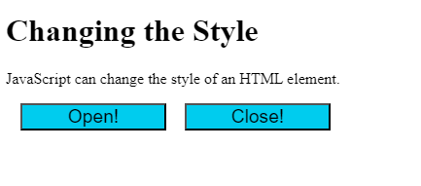

TASK:
- Using the Shopping List files from the previous videos update the shopping list app to do the following:
A. If you click on the list item, it toggles the .done class on and off.
B. Add buttons next to each list item to delete the item when clicked on its corresponding delete button.
C. BONUS: When adding a new list item, it automatically adds the delete button next to it (hint: be sure to check if new items are clickable too!)

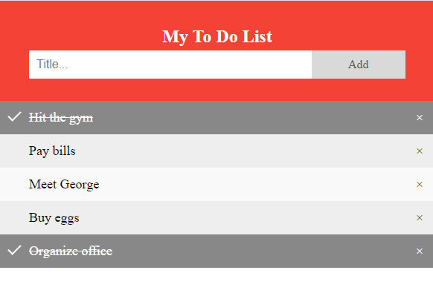

- Write a JavaScript program to calculate the volume of a sphere.
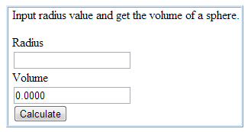

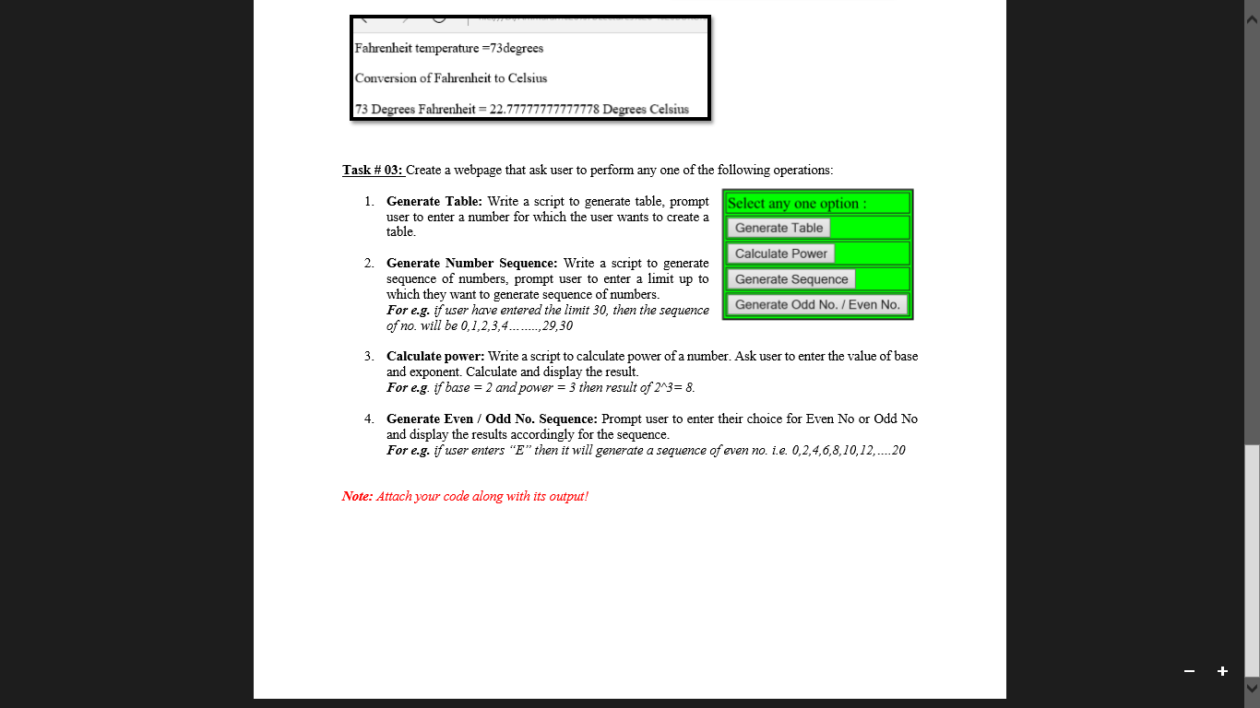
Task 4:
Create a document with multiple tabs with background color. Upon hover background color of the document is changed accordingly
